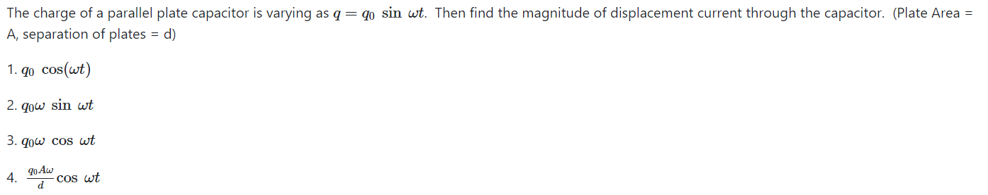
Ques:

Ans:
Differentiate to get the correct answer (also verify from the ampere’s law)

